Computer Language Coding Concepts

Related List Item in a Diagram
The concept of a related list item is explained in the article Related List Item. The current article demonstrates its expression in a diagram.

The diagram below displays the complete system interface of a related list item:

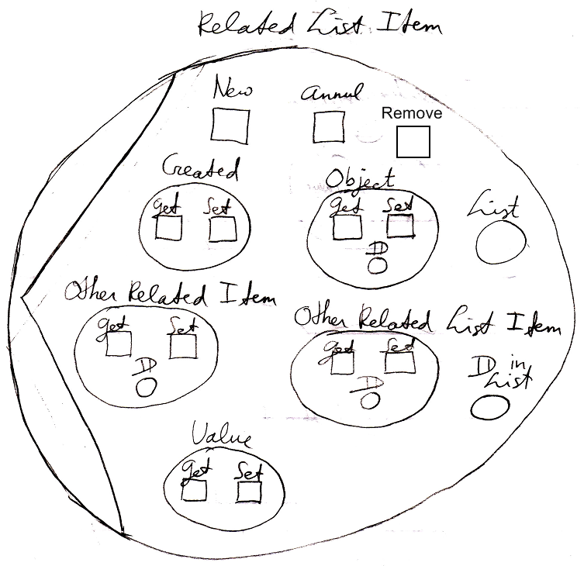

Part of a related list item’s system interface is a reference to the List and the registration of the related lists item’s ID in List as explained in the article Related List Item. The diagram above also shows other parts of the system interface, such as the Object part of the system interface and the Value part of the system interface. The specific members of the system interface of a related list item are covered in the articles:

- Object Get & Set
- Pointer To Pointer Get & Set
- Value Get & Set
- New & Annul
- Remove

See also: System Objects, Related List Item, Object Get & Set, Pointer To Pointer Get & Set, Value Get & Set, New & Annul, Remove

Author & Copyright: Jan-Joost van Zon Date: July 20, 2008 – July 24, 2008 Location: Oosterhout, The Netherlands Status: Finished

